**Assignment-3**

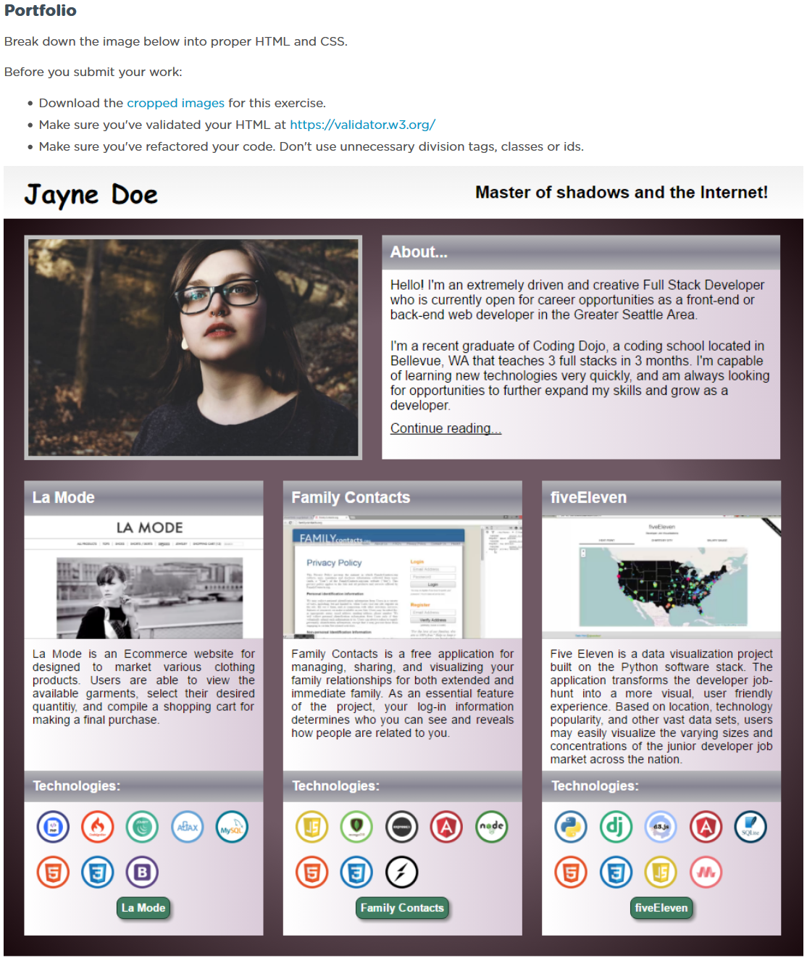

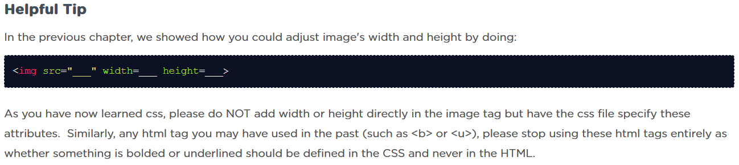

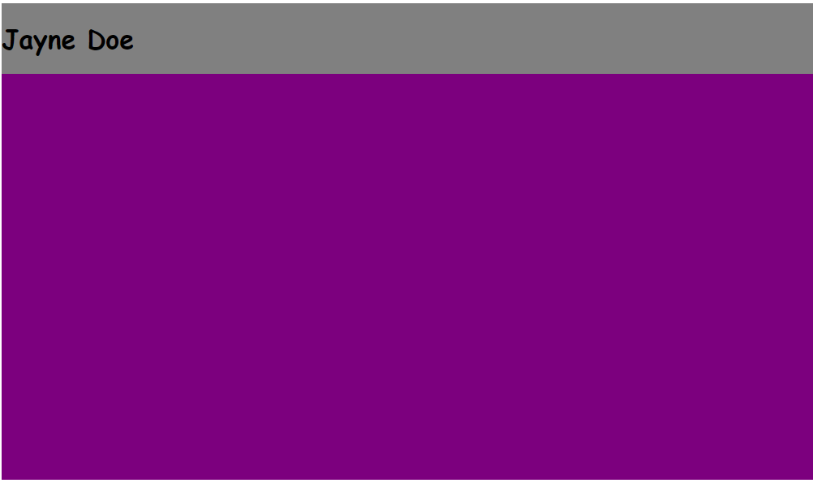

Commit: Main containers: Gray and purple (without gradients)

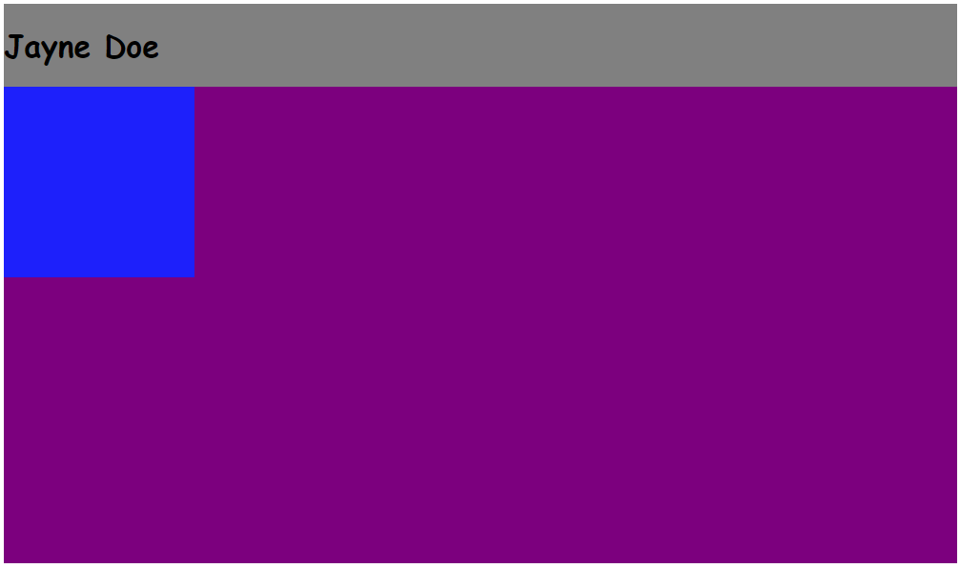

Commit: Floating box (upper left corner)

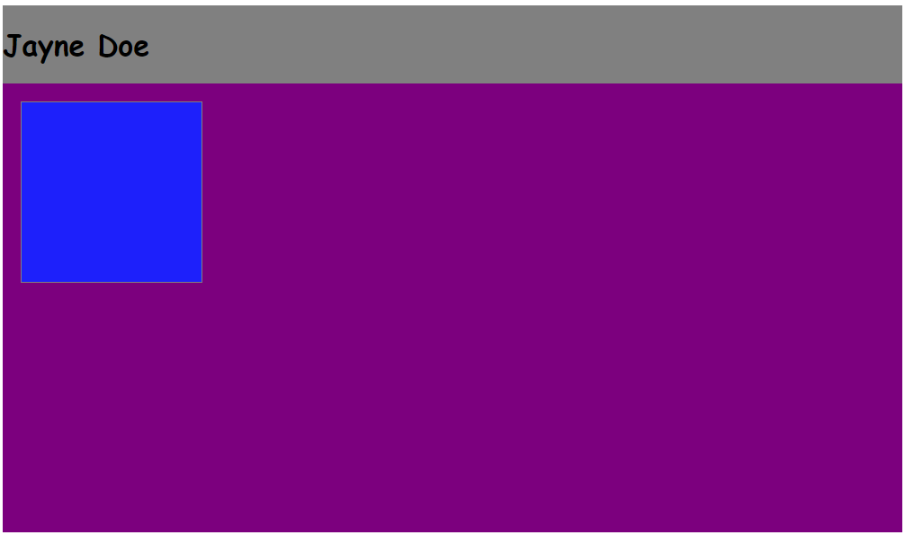

**Local**: D:\dev\bootcamp\01_Web-Fundamentals\02_CSS\02_portfolio

**Repo**: bootcamp

**Branch**: Master

**Commit**: Border and margin of upper left floating block.

**Note**:

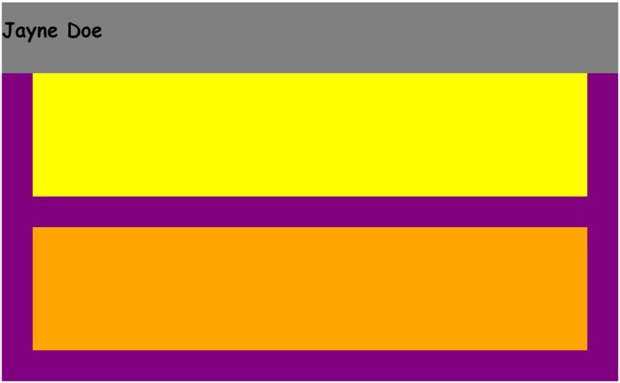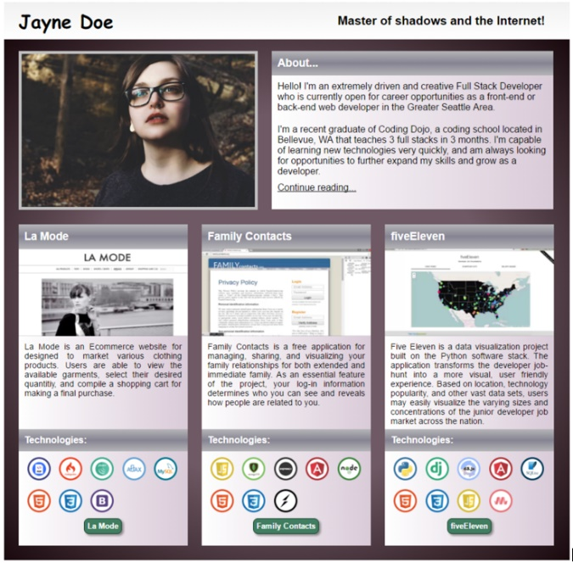

**Local**: C:\dev\CSS-3_portfolio

**Repo**: CSS-3_portfolio

**Branch**: Master

**Commit**: Added two rows.

**Note**:

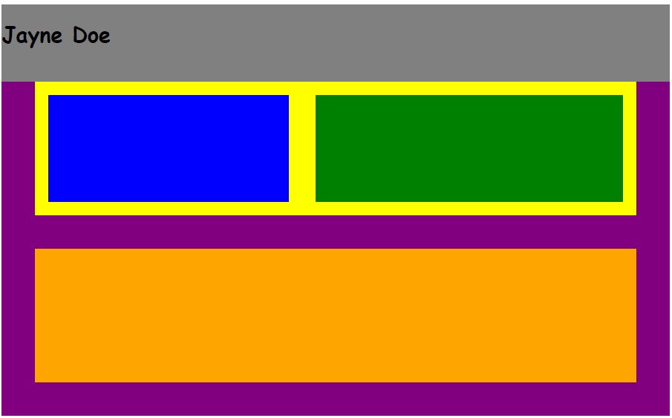

**Local**: C:\dev\CSS-3_portfolio

**Repo**: CSS-3_portfolio

**Branch**: Master

**Commit**: Added two blocks inside the top row.

**TODO**: Add rows inside bottom cols.

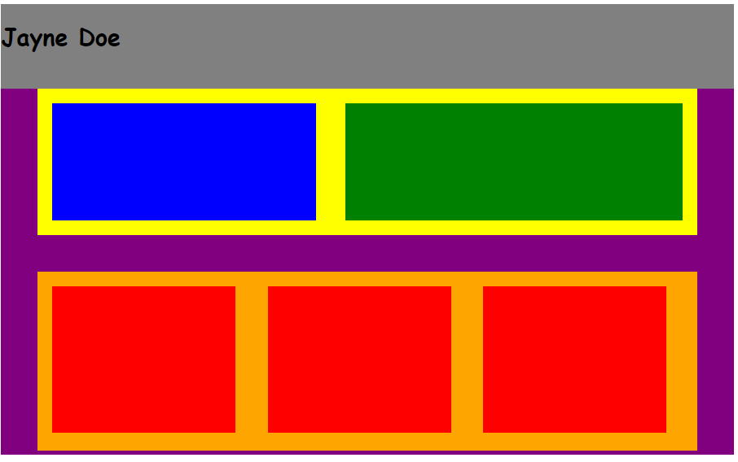

**Local**: C:\dev\CSS-3_portfolio

**Repo**: CSS-3_portfolio

**Branch**: Master

**Commit**: Add three cols inside row-2.

**TODO**: Add in two rows in each column in bottom row.

**Then**: Add in two rows inside these for the top grey bordertext

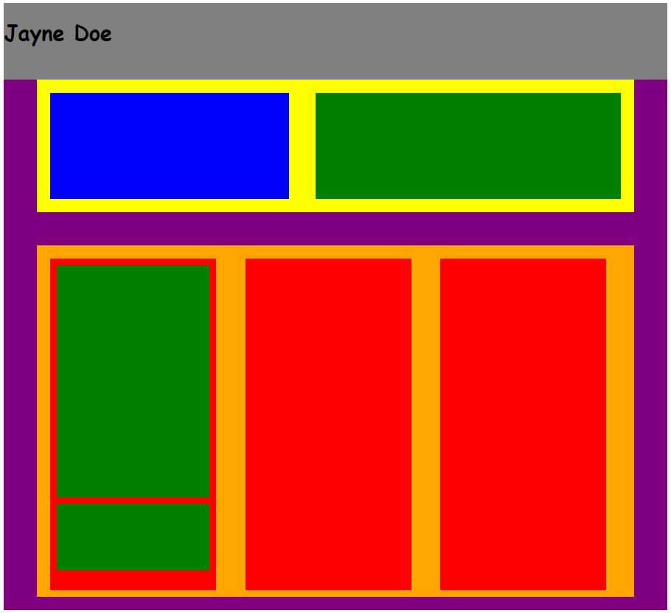

**Local**: C:\dev\CSS-3_portfolio

**Repo**: CSS-3_portfolio

**Branch**: Master

**Commit**: Add in two rows in each column in bottom row.

**TODO**: Add in two rows inside these for the top grey bordertext

**Then**: Add text to these newly added boxes.

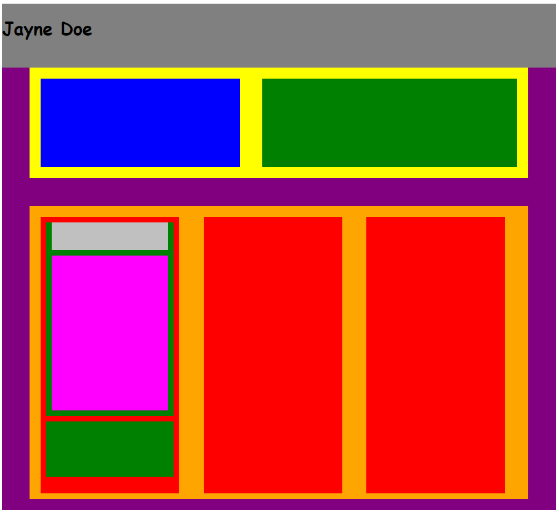

**Local**: C:\dev\CSS-3_portfolio

**Repo**: CSS-3_portfolio

**Branch**: Master

**Commit**: Add in two rows inside these for the top grey bordertext

**TODO**: Add text to these newly added boxes.

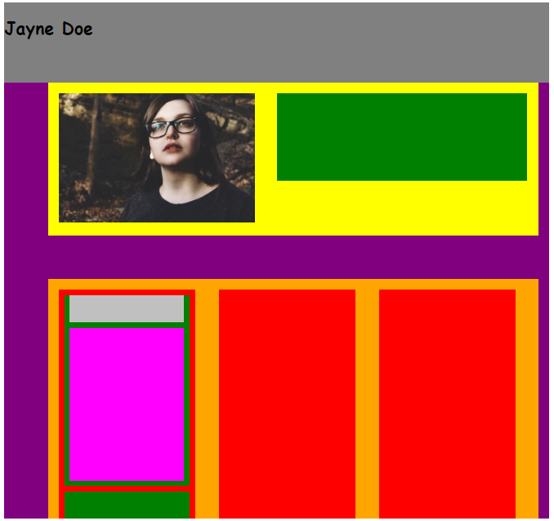

**Local**: C:\dev\CSS-3_portfolio

**Repo**: CSS-3_portfolio

**Branch**: Master

**Commit**: Added image

**TODO**: Add text to top right green box.

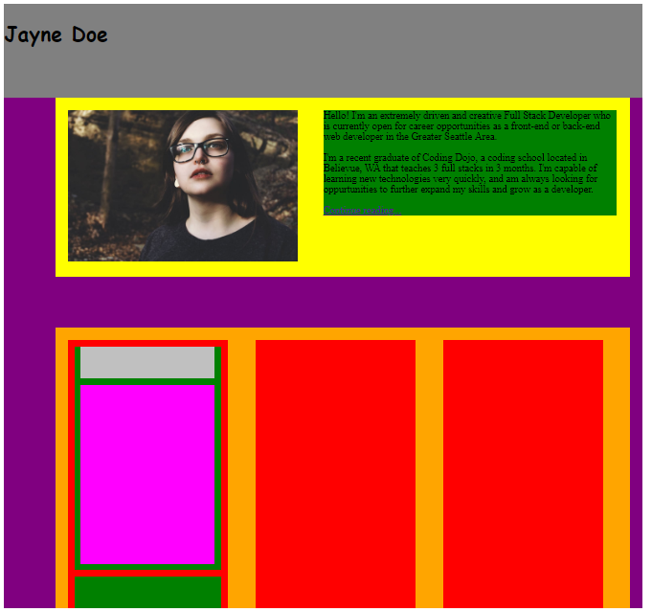

**Local**: C:\dev\CSS-3_portfolio

**Repo**: CSS-3_portfolio

**Branch**: Master

**Commit**: Added text to top right green box.

**TODO**: Add two boxes to green box, similar to as done in a previous step.

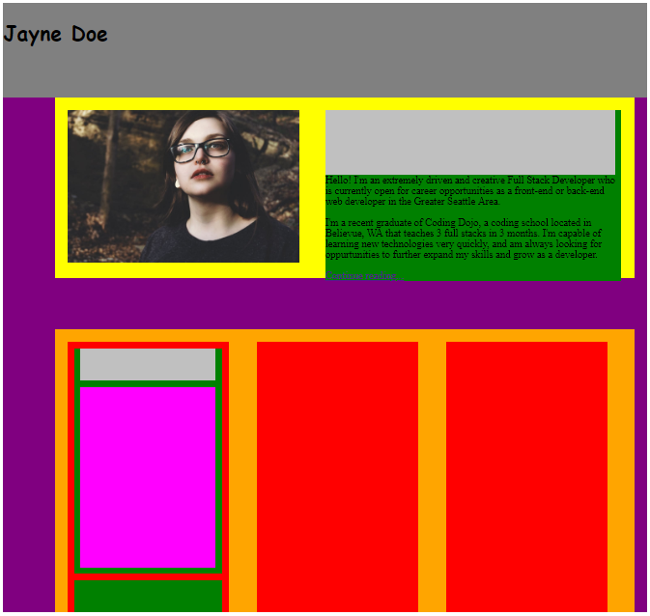

**Local**: C:\dev\CSS-3_portfolio

**Repo**: CSS-3_portfolio

**Branch**: Master

**Commit**: Added grey sub-box in the upper right box and moved the text below.

**TODO**: Change size of sub-boxes in the newly added green box.

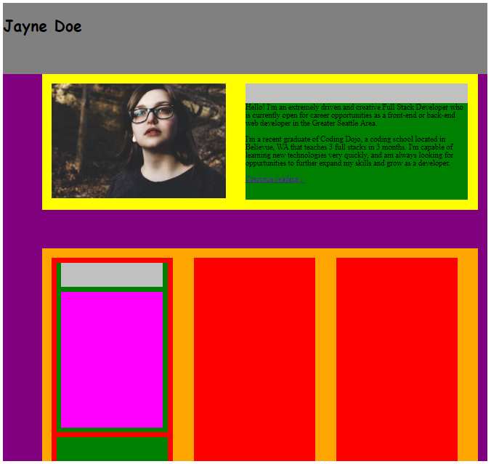

**Local**: C:\dev\CSS-3_portfolio

**Repo**: CSS-3_portfolio

**Branch**: Master

**Commit**: Got size of boxes in upper right box approximately where they ultimately need to be.

**TODO**: Add text to the grey strip in the upper right box.

**Then**: If works, then repeat process for the columns in the

second row.

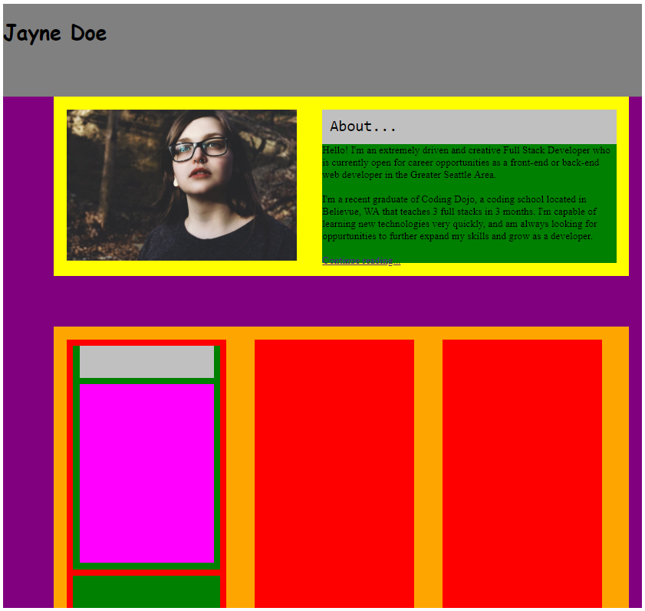

**Local**: C:\dev\CSS-3_portfolio

**Repo**: CSS-3_portfolio

**Branch**: Master

**Commit**: Added text in header in upper right box (“About…”)

**TODO**:Repeat process for the columns in the second row.

**Local**: C:\dev\CSS-3_portfolio

**Repo**: CSS-3_portfolio

**Branch**: Master

**Commit**: Started over from scratch using the technique of superimposing the spec onto my design.

**TODO**:

* Add top div
* Add upper left image.
* Add upper right div.
* Add in first div below the image.
* Add in next two center divs
* Add in footer div.

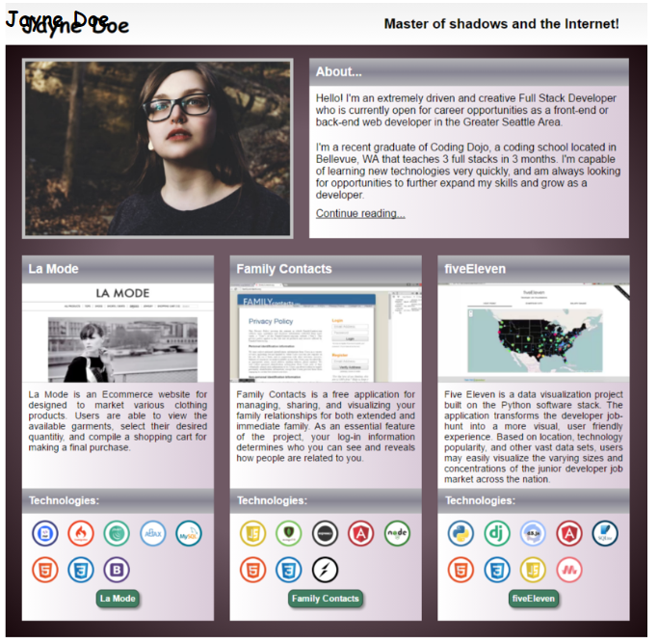

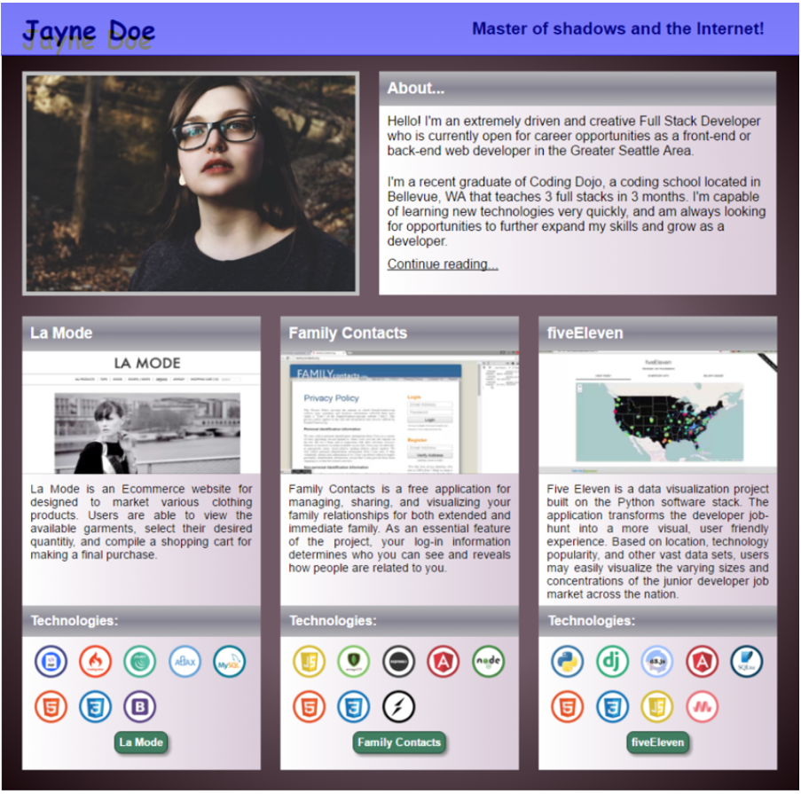

**Local**: C:\dev\CSS-3_portfolio

**Repo**: CSS-3_portfolio

**Branch**: Master

**Commit**: Added top div.

**TODO**:

* ~~Add top div~~
* Add upper left image.
* Add upper right div.
* Add in first div below the image.
* Add in next two center divs
* Add in footer div.

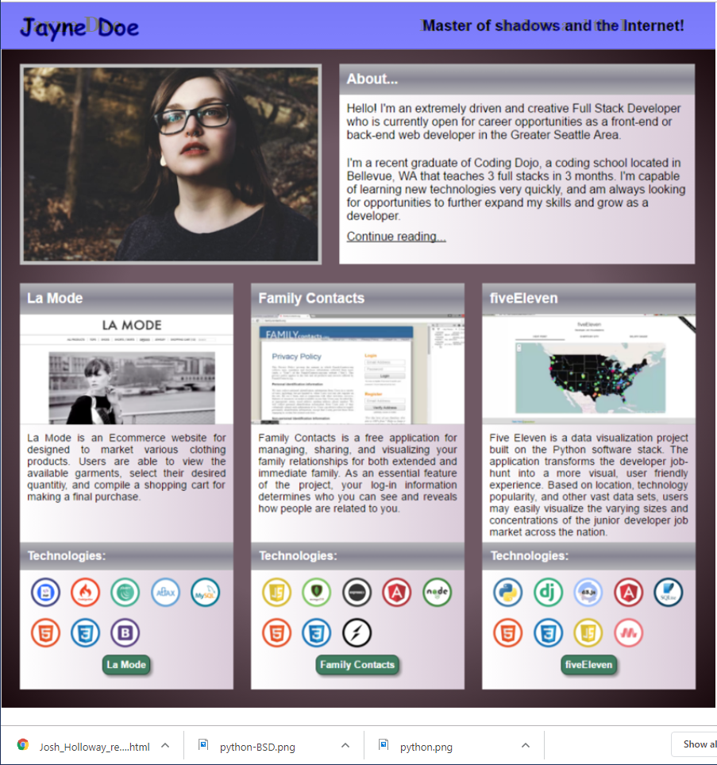

**Local**: C:\dev\CSS-3_portfolio

**Repo**: CSS-3_portfolio

**Branch**: Master

**Commit**: Added upper right text.

**TODO**:

* ~~Add top div~~
* Add upper left image.
* Add upper right div.
* Add in first div below the image.

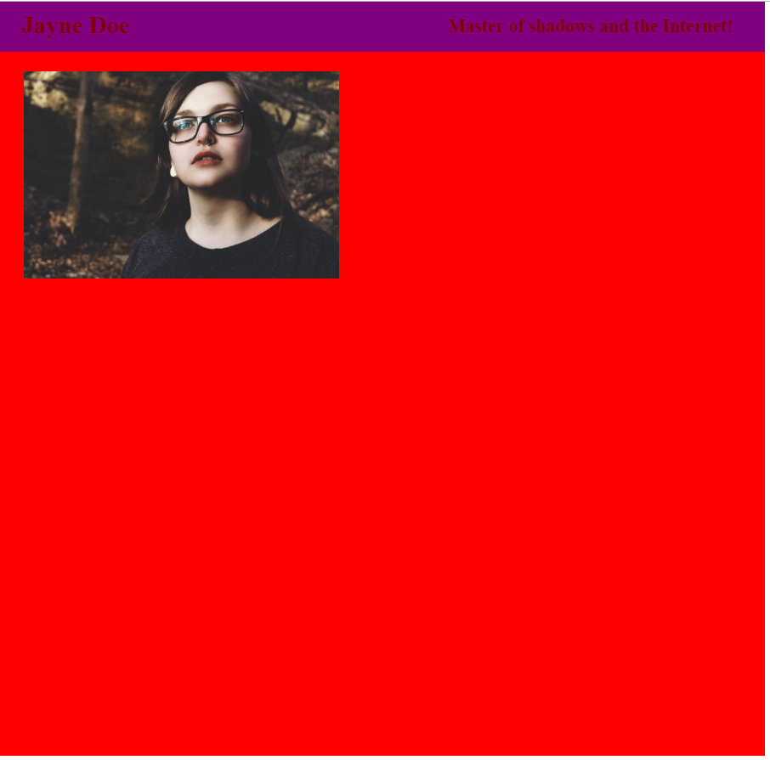

**Local**: C:\dev\CSS-3_portfolio

**Repo**: CSS-3_portfolio

**Branch**: Master

**Commit**: Added top left image.

**TODO**:

* ~~Add top div~~
* ~~Add upper left image.~~
* Add upper right div.
* Add in first div below the image.
* Add in next two center divs
* Add in footer div.

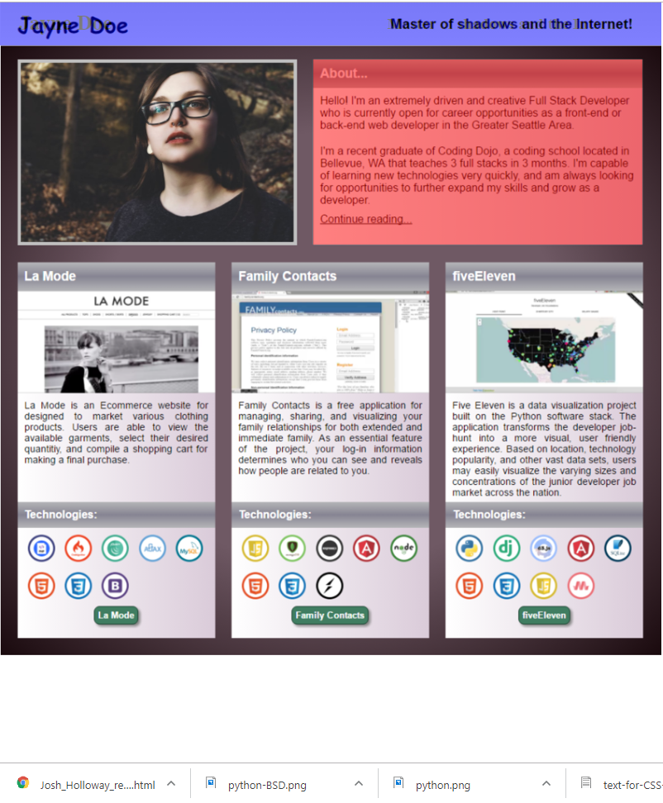

**Local**: C:\dev\CSS-3_portfolio

**Repo**: CSS-3_portfolio

**Branch**: Master

**Commit**: Added upper right box (About…)

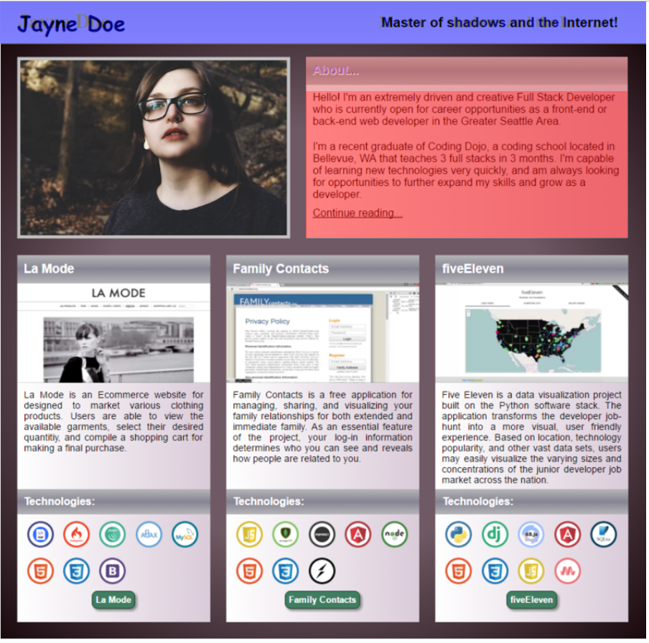

**Local**: C:\dev\CSS-3_portfolio

**Repo**: CSS-3_portfolio

**Branch**: Master

**Commit**: Added title-text in upper right box.

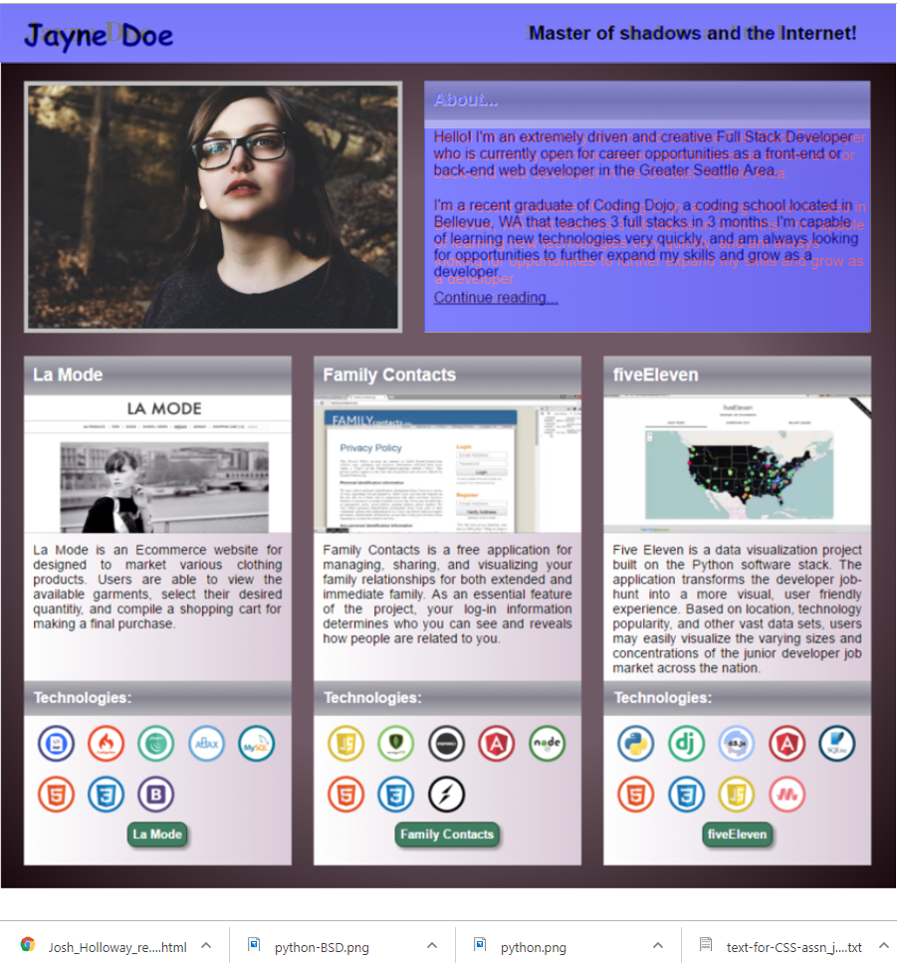

**Local**: C:\dev\CSS-3_portfolio

**Repo**: CSS-3_portfolio

**Branch**: Master

**Commit**: Added body-text in upper right hand corner.

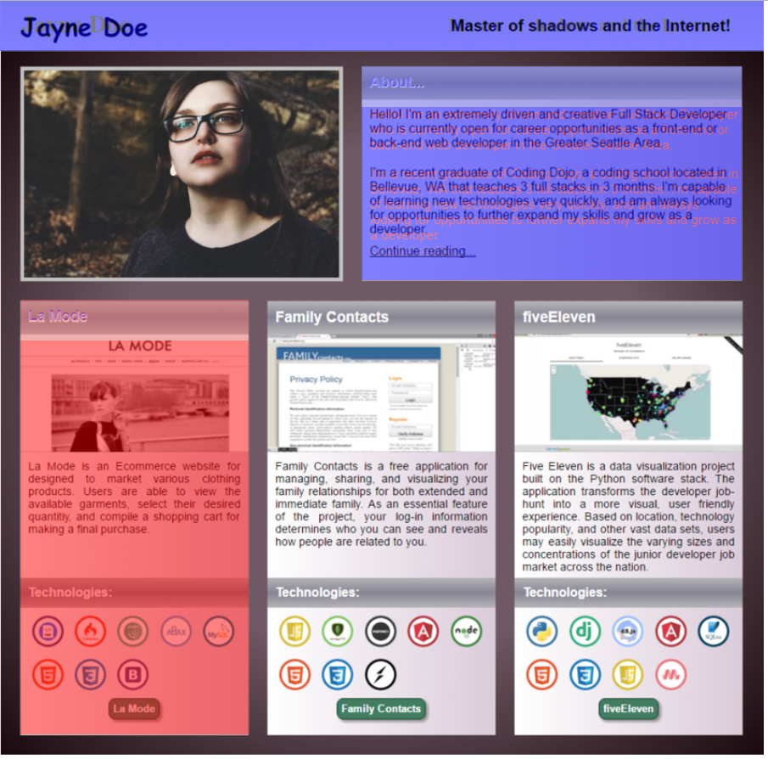

**Local**: C:\dev\CSS-3_portfolio

**Repo**: CSS-3_portfolio

**Branch**: Master

**Commit**: Added left column.